A website’s navigation should be fairly self-explanatory. That is, a user who navigates to your website should be able to look at the navigation system you have designed and be able to navigate to the page of their choosing. This is done without any explanation on behalf of the navigation system. Another good practice, especially if the website is selling any products, is to allow the unrestricted access to any user wishing to view the site and/or your products on the website. You do not want to hinder the user’s ability or desire to view your products in any way.

The <http://strategicplan.bournemouth.ac.uk/> website has a very unusual navigation system. It is so unusual it required the planners and/or designers to install a link to a guide describing how the navigation system works. In order to even you the navigation, you must click a link in the middle of the page. This opens a diagram with what looks like a racetrack and an infield with circles in different places around the racetrack. You must click on the circles, and some other places to navigate the website. This is an absolute horrid design. Anyone with disabilities would not be able to navigate the site as there is no other way to do so. [Google’s Mobile Friendly Test](https://www.google.com/webmasters/tools/mobile-friendly/?utm_source=psi&utm_medium=referral&utm_campaign=uxresults&url=http%3A%2F%2Fstrategicplan.bournemouth.ac.uk%2F) says it’s awesome and mobile-friendly, it must not test this particular page or the navigation system. I tried the site on my tablet

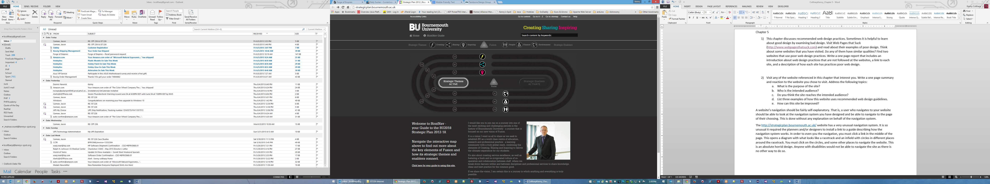

The [“Touch Of Modern”](https://www.touchofmodern.com/) website appears to be a site that offers products for sale on the Internet. However, they require the creation of an account before access is allowed. Although, the homepage looks appealing, unless you wish to create an account with “Touch of Modern”, whoever they are, you cannot even look at the products they offer, if any at all.